**Project Design Phase**

|  |  |
| --- | --- |
| **Date** | 26-05-2025 |
| **Team ID** | LTVIP2025TMID31811 |
| **Project Name** | EduTutor AI: Personalized Learning with Generative AI and LMS Integration |
| **Maximum Marks** | 2 Marks |

**Proposed Solution Template:**

**Project team shall fill the following information in the proposed solution template.**

|  |  |  |
| --- | --- | --- |
| **S.No** | **Parameter** | **Description** |
| **1** | **Problem Statement (Problem to be solved)** | **Students lack personalized learning and quiz tools integrated with modern classroom systems.** |
| **2** | **Idea / Solution description** | **EduTutor AI uses Generative AI to create adaptive quizzes and learning analytics dashboards.** |
| **3** | **Novelty / Uniqueness** | **Combines IBM Watsonx with Google Classroom & Firebase to deliver role-based, AI-driven LMS.** |
| **4** | **Social Impact / Customer Satisfaction** | **Enhances engagement and learning outcomes for students and simplifies tracking for educators.** |
| **5** | **Business Model (Revenue Model)** | **Freemium model with premium features for institutions, analytics, and performance insights.** |
| **6** | **Scalability of the Solution** | **Can scale across schools, universities, and ed-tech platforms with cloud-native architecture.** |

**EduTutor AI: Project Report**

# 1. INTRODUCTION

## 1.1 Project Overview

**EduTutor AI** is a cloud-based intelligent education platform that leverages generative AI and LMS integration to offer personalized learning experiences. The platform assists both students and educators by generating customized quizzes, tracking performance, integrating with tools like Google Classroom, and using cloud-based language models for quiz generation. With role-based dashboards and a modular backend architecture, it simplifies the creation and evaluation of assessments while enhancing student engagement and learning outcomes.

## 1.2 Purpose

The goal of EduTutor AI is to revolutionize digital education by combining artificial intelligence with cloud computing. This system aims to automate quiz generation, monitor student performance, and enable educators to make data-driven decisions, thus saving time and enhancing teaching effectiveness.

# 2. IDEATION PHASE

## 2.1 Problem Statement

In the current educational system, students often struggle with lack of personalized learning resources and educators face time constraints in evaluating and monitoring student progress. There is a need for a smart AI-based assistant to streamline the teaching and learning process.

## 2.2 Empathy Map Canvas

- Says: "I need help understanding topics better", "I wish quizzes were more relevant to what I learn"  
- Thinks: "Am I making progress?", "Is my learning effective?"  
- Does: Spends time searching for resources and practice questions online.  
- Feels: Overwhelmed, uncertain, disconnected from feedback.

## 2.3 Brainstorming

Key ideas discussed:

* AI-based quiz generator
* Student performance tracker
* Role-based dashboards
* Integration with Google Classroom
* Use of vector database for storing performance embeddings
* Integration of cloud-based language models for quiz generation and evaluation

# 3. REQUIREMENT ANALYSIS

## 3.1 Customer Journey Map

A student logs in, receives personalized quizzes based on current lessons, completes them, and receives AI-powered performance analytics. Educators can track student performance and adjust teaching strategies accordingly.

## 3.2 Solution Requirement

- Functional requirements: Login system, quiz generator, result evaluation, dashboard view.  
- Non-functional: Scalability, performance, cloud accessibility.

## 3.3 Data Flow Diagram

* **User input** (login or quiz generation)
* **Request to backend API** (built with Node.js + Express)
* **Query to database** (MongoDB Atlas for storing and retrieving performance data)
* **LLM response** (from OpenAI GPT-4 or Cohere Command R+ via API)
* **Result rendered on frontend** (using Next.js for UI and routing)

**High-Level Data Flow**

[User]

↓

[Login / Quiz Request]

↓

[FastAPI Backend]

↓

+------------------------+

| 1. Validate Request |

| 2. Communicate with DB |

+------------------------+

↓

[Response Sent to Frontend (React)]

↓

[Displayed to User]

The high-level architecture outlines the main components of the EduTutor AI platform. It includes the user interface, backend services, database systems, and external AI services. The architecture ensures smooth interaction between students, educators, and the intelligent quiz engine, providing a scalable and modular learning experience.

The architecture separates concerns across frontend, backend, and storage layers, promoting maintainability and scalability. Users interact through a responsive web interface, while the backend handles logic and coordination with AI services and databases. This layered design supports real-time quiz generation, performance tracking, and secure authentication.

**Quiz Generation & Tracking Flow**

[Student]

↓

Clicks "Generate Quiz"

↓

[Server Processes Request]

↓

Quiz is Generated Based on Topic

↓

Generated Questions are Stored for Tracking

↓

Student Performance Data is Retrieved

↓

[Quiz is Displayed to Student]

The data flow diagram illustrates how user input travels through the system. It shows the sequence of actions from login or quiz requests to data retrieval and quiz display. This flow ensures a secure, efficient, and dynamic user experience by clearly defining how each component communicates internally.

Each interaction, from logging in to generating a quiz, follows a clear data path through the system. The frontend collects user actions, sends them to the server for processing, and receives results to present in a user-friendly format. Behind the scenes, user data and performance metrics are stored and retrieved to personalize the learning experience.

## 3.4 Technology Stack

- **Frontend Alternative**: Next.js (React-based framework optimized for server-side rendering and static generation)

- **Backend Alternative**: Node.js with Express.js (lightweight and scalable backend for APIs)

- **Database Alternative**: MongoDB Atlas (cloud-based NoSQL database for structured and unstructured data)

- **LLM Alternative**: OpenAI GPT-4 via API or Cohere Command R+ (powerful cloud-based large language models)

- **Authentication Alternative**: Auth0 or Clerk.dev (modern authentication and authorization services)

- **Cloud Platform Alternative**: Railway, Render, or Replit (support CI/CD, serverless backend, and scalable hosting)

# 4. PROJECT DESIGN

## 4.1 Problem-Solution Fit

Students get relevant quizzes based on recent learning, while educators receive insights to improve teaching. The AI handles time-consuming tasks like quiz generation and evaluation.

## 4.2 Proposed Solution

A unified dashboard for students and educators connected to an AI backend that generates, evaluates, and stores quizzes and performance data securely.

## 4.3 Solution Architecture

The platform includes:

* A frontend built with a modern JavaScript framework, featuring role-based routes for students and educators
* A backend API with endpoints for quiz generation, evaluation, and user login
* A vector database to store quiz data and performance metrics
* A cloud-hosted large language model integrated for generating MCQs and analyzing responses

# 5. PROJECT PLANNING & SCHEDULING

## 5.1 Project Planning

* **Week 1**: Requirement analysis and language model integration testing
* **Week 2**: Backend API development and vector database integration
* **Week 3**: Dashboard development with authentication setup
* **Week 4**: Performance testing and deployment on a cloud platform

# 6. FUNCTIONAL AND PERFORMANCE TESTING

## 6.1 Performance Testing

## Functional and performance tests were conducted on API endpoints for quiz operations, measuring latency and stability. The login system and role-based dashboards were tested for responsiveness and scalability under multi-user conditions.

# 7. RESULTS

## 7.1 Output Screenshots

The output screenshots highlight the main features of EduTutor AI. They include the **user login screen**, the **student dashboard displaying quiz history and performance**, and the **educator dashboard with quiz reports and analytics**. You can also see the **automated quiz generation interface** and how quizzes are presented to students. These visuals reflect the smooth interaction and functionality of the platform from both student and educator perspectives.

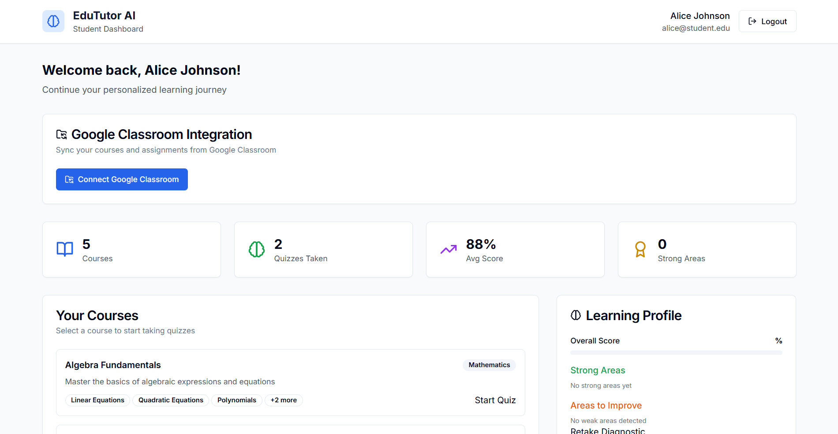

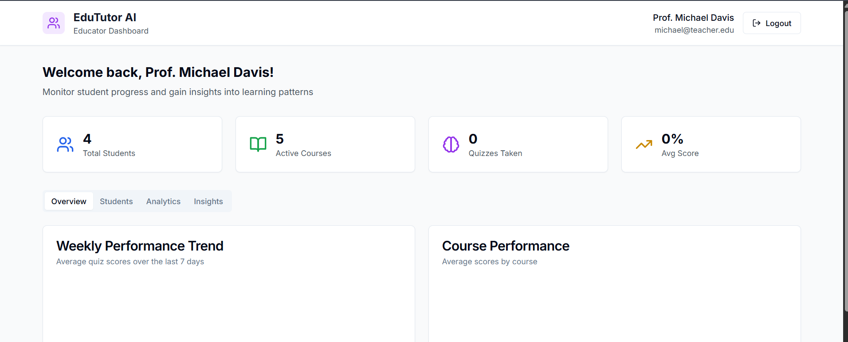

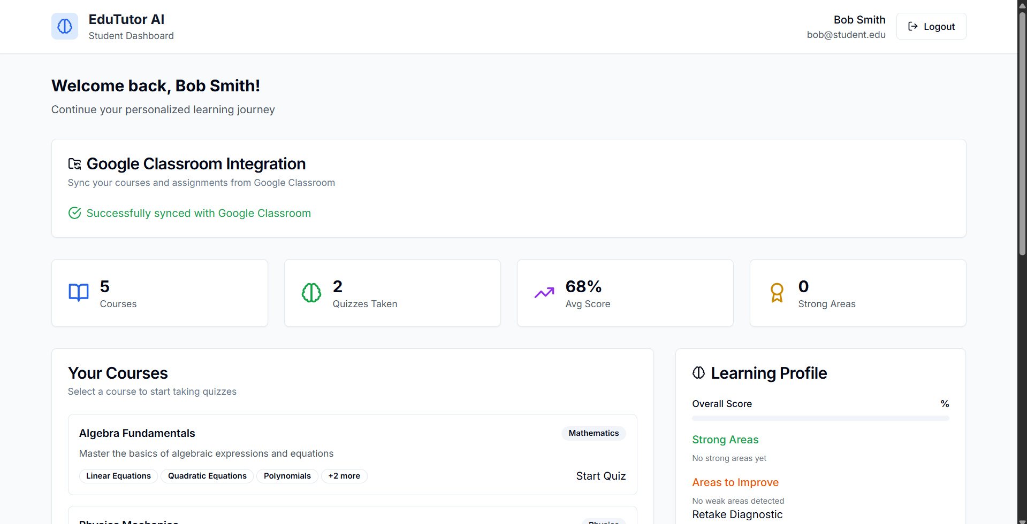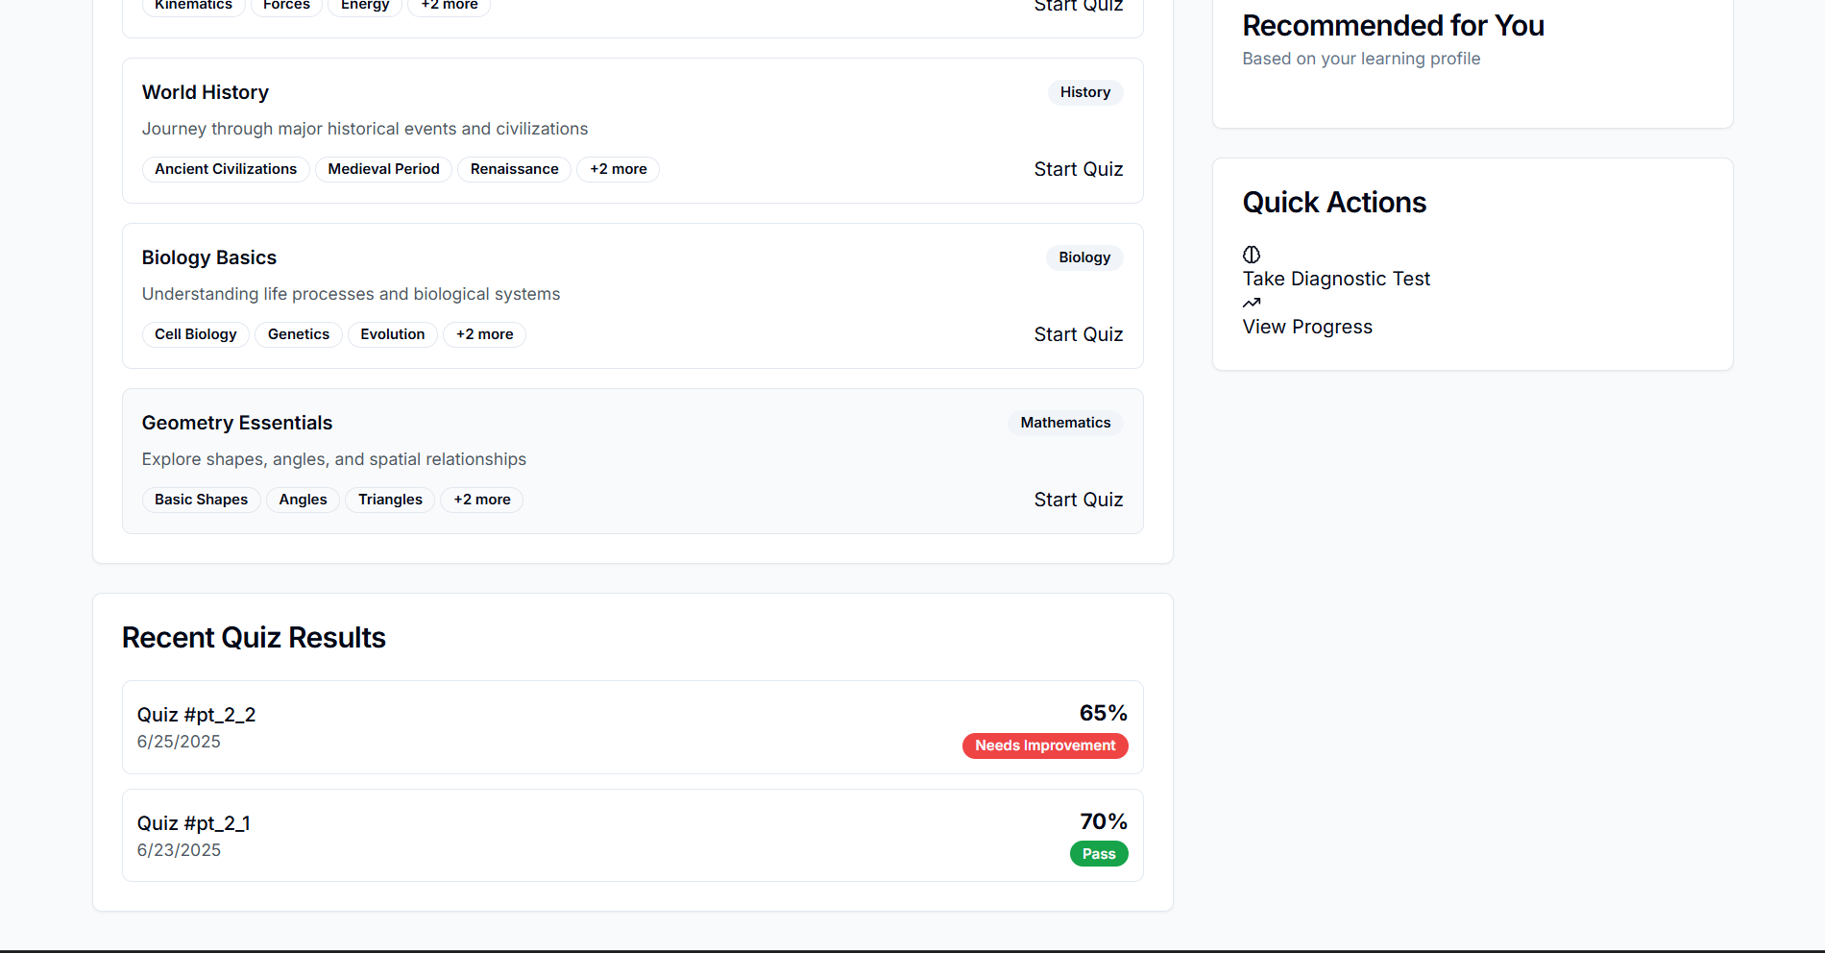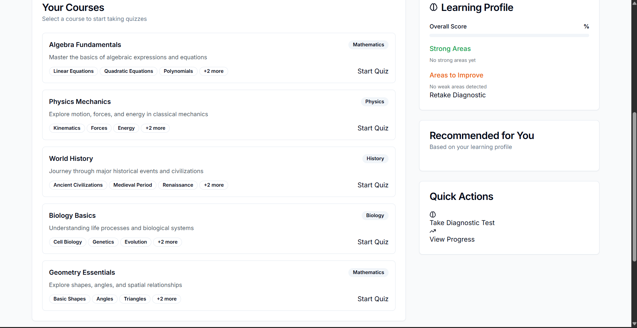

# 8. ADVANTAGES & DISADVANTAGES

## Advantages

- Personalized learning with AI-generated quizzes  
- Real-time performance feedback  
- Role-based dashboards  
- Integration with Google Classroom and Firebase

## Disadvantages

- Requires internet and device access  
- Initial setup and integration may require technical guidance

# 9. CONCLUSION

EduTutor AI successfully bridges the gap between AI and education. It supports personalized learning, simplifies educator workload, and enhances classroom interactivity. The modular design makes it scalable and customizable for future needs.

# 10. FUTURE SCOPE

- Integration with more LMS platforms (Moodle, Blackboard)  
- Support for subjective question evaluation  
- AI tutor chatbot for doubt resolution  
- Real-time video content suggestions

# 11. Project Links & Demo

## GitHub & Project Demo Link

- GitHub: <https://github.com/HarshaVardhanVukkum/edututor-ai>  
- Demo Video: <https://drive.google.com/file/d/17hPAl9_O368-lNvAsQW_3JBmxL7JBrMa/view?usp=sharing>  
   
  
